SIFTGPU Matlab Tutorial

This tutorial explains how to use SIFTGPU from the Matlab environment.

SIFT GPU can only be used on a machine containing a graphics card which supports OpenGL 2.0 (i.e. DirectX 9.0) or above, with a 32-bit Windows operating system. You should be able to find out if your graphics card is supported by doing a quick online search

SIFTGPU is coded in C++ and must be saved as a .mex (matlab external) file before it can be called from Matlab. In order to create the .mex file, you must make sure that Matlab is set up to access an external C++ compiler by entering

mex –setup

into the Matlab command window and following the on-screen instructions.

After that setup is complete, make sure that the current directory is the one containing the SIFTGPU functions and any images that you want to analyse.

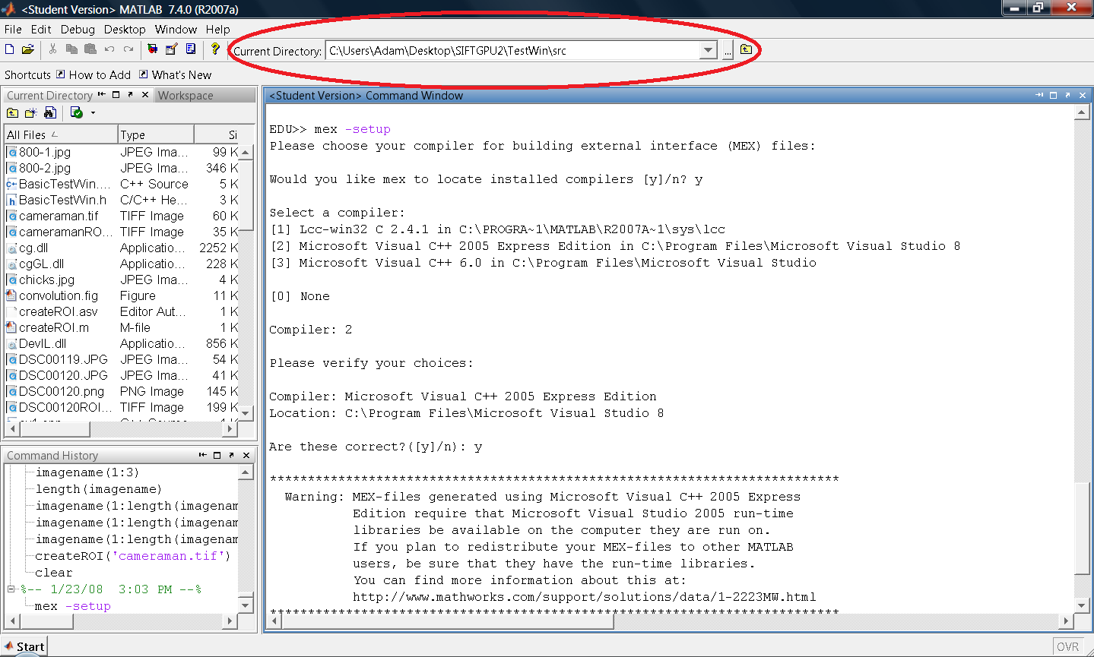
Figure 32. The current directory is set in Matlab using the highlighted browser bar.

If you want to use a region of interest to highlight a particular part of a library image, you need to reduce all the image intensities to 90% of their original value, using the function createROI, for example:

createROI('Blue1.jpg')

Matlab will then tell you that an image has been stored and is ready to have its ROI highlighted in white using Windows paint, e.g.

An image named Blue1ROI.tif is now saved in the folder
C:\Users\Adam\Desktop\SIFTGPU\TestWin\src. Open windows
paint and paint over the region of interest in white, then save the image under its current name in its current directory.

Open the image in paint and highlight your region of interest in white:

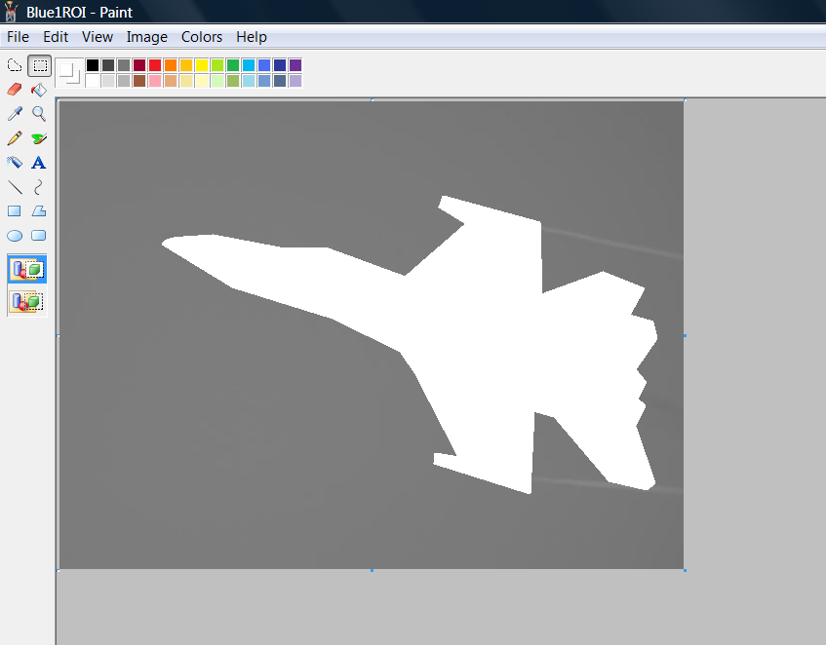
Figure 33. Highlighting the ROI in paint

It should be noted the matching algorithm can run when an ROI is not defined, although the potential accuracy of feature matching will be reduced.
Open the m-file siftdemo.m in the Matlab editor.

Type the name of your original image in the place of ‘Blue1.jpg’, highlighted below.
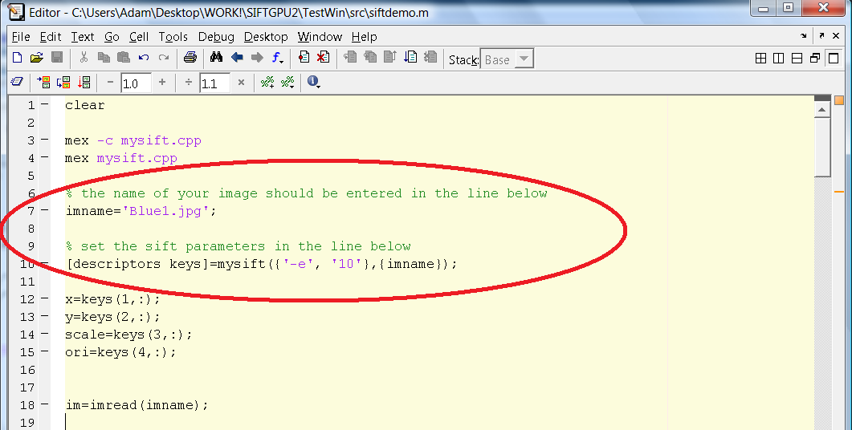
Figure 34. Defining SIFT parameters and image name.

Any tuning parameters also need to be set at this stage, in the format of:
[descriptors keys]=mysift({‘-parameter’, ‘value’ , ‘-parameter’, value’},{imname});

A quick reference table of SIFT parameters in presented in the appendix.

Pressing the F5 key from the editor window or typing siftdemo and pressing the enter key in the Matlab command window will run the siftdemo code.

A new figure window will pop-up, displaying the descriptor window regions superposed over the original image, from which you can see if too much background data is modelled in the descriptors, and suitably modify SIFT parameters.
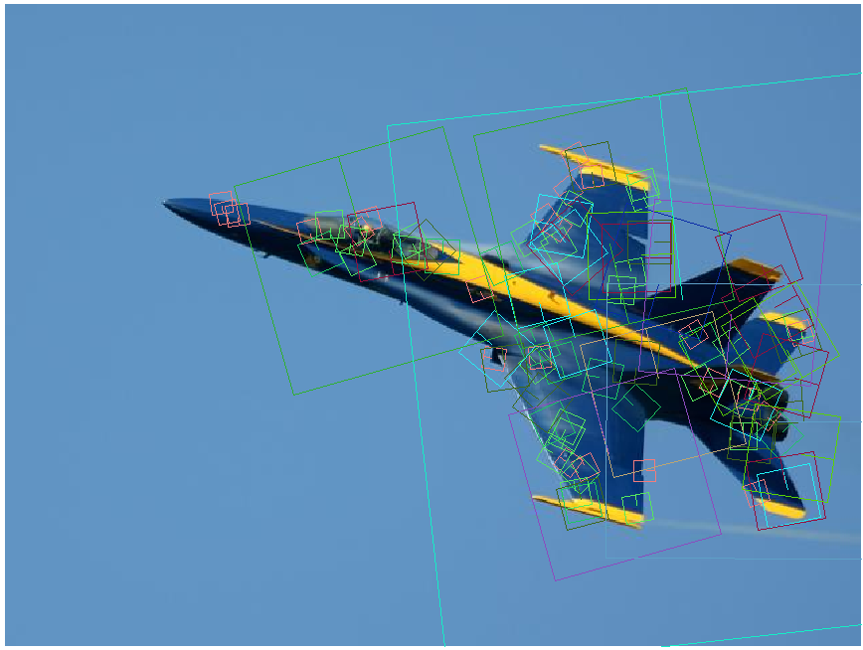
Figure 35. Descriptor windows superposed over the original image.

In the command window, the user is asked if the data should be stored. In this case we do, so we enter the yes.

Do you want to store that data? (1-yes, 2-no): 1
Do you want to match the descriptors with the database? (1-yes, 2-no): 2

We do not want to match the descriptors in this image with the ones we have stored, because we would simply be matching two exact copies of the same image features.

Let us introduce a new image to the system by defining the image name as ‘Blue2.jpg’ in the siftdemo.m file (figure 34).

Now we save and run siftdemo.m again. The descriptor regions are displayed in a new figure window again. Repeat the entries below in the command window to induce the feature matching process.

Do you want to store that data? (1-yes, 2-no): 1
Do you want to match the descriptors with the database? (1-yes, 2-no): 2

The match results are displayed in a new figure window. Note that matching accuracy will differ between separate graphics cards due to differences in floating point precision in the descriptor construction.

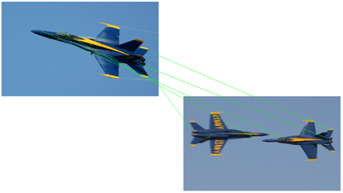
Figure 36. Matching Algorithm output.
Appendix. Quick-reference Table of GPUSIFT parameters

-f <Factor> | Filter width will be 2*factor*sigma+1 (default : 3.0)
-w <factor> | Orientation window will be 2*factor (default : 3.0)
-dw <factor> | Descriptor grid size is 4*factor*sigma (default : 3.0)
-fo <first> | First Octave (default: 0)
-no <number> | Maximum number of octaves (default: not limit)
-d <dog levels> | DOG levels in an octave (default: 3)
-t <threshold> | DOG threshold (default: 0.04/3)
-e <threshold> | Edge Threshold (default : 10.0)
-m <num=2> | Number of possible Feature Orientations (default : 1)
-s | Enable sub-pixel, sub-scale Localization

Courtesy of Changchang Wu^{c6}

